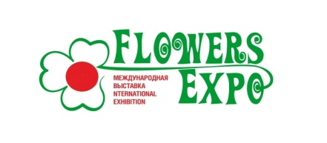
International Exhibition «FlowersExpo»

Moscow, International exhibition centre «Crocus Expo»
Pavilion 1, September 13 - 15, 2022

Application for press accreditation

- The accreditation is free of charge.
- Using and coping of the materials of the exhibition’s press-centre is allowed only if will be the indication that the info was from the official web-site: http://www.flowers-expo.ru

The name of the company_____________________________________________
Address ___________________________________________________________
Phone (with area code):
Fax (with area code): _________________________________________________
E-mail: ____________________________________________________________
Names
Position:

Date « » 2022

Signature:

Press-centre of the exhibition:
Phone: + 7 (495) 118-06-39
E-mail: flowersexpo@mail.ru
mail@flowers-expo.ru

