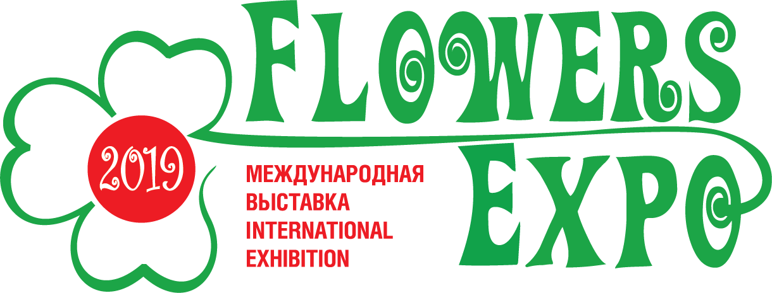

International Exhibition «FlowersExpo»
Moscow, International exhibition centre «Crocus Expo»
September 10 - 12, 2019
E-mail: mail@flowers-expo.ru
www.flowers-expo.ru

Application for accreditation
Name mass media _____________________________________
Name of the journalist ___________________________________
Position ______________________________________________
Phone _______________________________________________
Email _______________________________________________

Internet _____________________________________________

Signature __________________

